Chapter 4: Resources

4.1 Resources on Earth are either renewable or non-renewable

Literacy support worksheet answers (pages 62–63)

Renewable and non-renewable resources

1Look at each picture below and write whether it is a continuous, renewable or non-renewable resource.

|  |  |  |
| --- | --- | --- |
| **Resource Image** | **Type of Resource** | **Overview of the resource** |
| L:\1. Publishing and Editorial\1. Product\Oxford Science\Oxford Science 7\3. Extras\4. Answers\Artwork\4. Final jpgs\WS0409_00883.jpg | Continuous | Ocean waves can be used to generate electricity |
| L:\1. Publishing and Editorial\1. Product\Oxford Science\Oxford Science 7\3. Extras\4. Answers\Artwork\4. Final jpgs\WS0410_00883.jpg | Renewable | Plants are regrown with the seeds they produce |
| L:\1. Publishing and Editorial\1. Product\Oxford Science\Oxford Science 7\3. Extras\4. Answers\Artwork\4. Final jpgs\WS0411_00883.jpg | Continuous | Wind is used to turn turbines to generate electricity |
| L:\1. Publishing and Editorial\1. Product\Oxford Science\Oxford Science 7\3. Extras\4. Answers\Artwork\4. Final jpgs\WS0412_00883.jpg | Non-renewable | Electricity is generated from the burning of coal |
| L:\1. Publishing and Editorial\1. Product\Oxford Science\Oxford Science 7\3. Extras\4. Answers\Artwork\4. Final jpgs\WS0413_00883.jpg | Renewable | Forests can be replanted after logging occurs |
| L:\1. Publishing and Editorial\1. Product\Oxford Science\Oxford Science 7\3. Extras\4. Answers\Artwork\4. Final jpgs\WS0414_00883.jpg | Non-renewable | Oil is extracted and is one of the world’s most commonly used energy sources |

2 Renewable or non-renewable? Circle the correct answer for each of the resources below using your knowledge of environmental resources.

a Petrol for your family car:

Non-renewable

b The wind that turns a turbine:

Renewable

c The coal that provides electricity:

Renewable

d The water you drank yesterday:

Renewable

e A plastic wrap you had your lunch in:

Renewable

2Energy from the Sun is a renewable resource called solar power. In the box below, write and draw diagrams of inventions that use solar power.

Any well-known uses of solar power are applicable here, as well as any created forms.

3 Energy from the Sun is a renewable resource called solar power. In the box below, write and draw diagrams of inventions that use solar power.

Student answers will vary.

WORD DETECTIVE

4 Match-a-word

Draw a line from the words to their meanings.

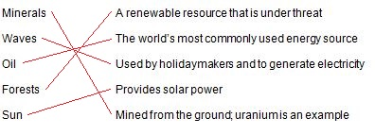

4.2 Renewable resources can be quickly replaced

Literacy support worksheet answers (pages 64–65)

Replaceable resources

1The pie chart shows the use of Australia’s energy resources.

aRank the energy resources from highest percentage use to the lowest.

Coal, gas, hydro, wind, crude oil, solar, geothermal

bList the energy resources that are from renewable energy sources.

Solar, wind, geothermal and hydro are renewable energy sources.

cHow much energy comes from renewable resources?

6.2% of Australia’s energy comes from renewable resources.

d Look at the pie chart showing Australia’s mining exports. How do you think the exports might affect the environment when used overseas?

Australia exports coal to other countries of the world. These countries would burn the coal to generate electricity, which would contribute to greenhouse gas emissions.

2Use the pictures at the bottom of the map of Australia (Legend) in the textbook, to answer the following questions.

aWhere are most of the wind power stations found?

Most wind power stations are found on the coast or just off-shore in Victoria, South Australia and Tasmania

bWhy do you think the wind power stations are found next to the sea (the coast) in Australia?

Student responses will vary, but factors such as wind speed and proximity to major cities could be considered.

cWhere in Australia are most of the coal energy resources found?

Most coal energy reserves are found in eastern Australia, especially in a line through Queensland and into New South Wales, with another place in Victoria.

WORD DETECTIVE

3 Word search

Find the words listed, in the puzzle below.

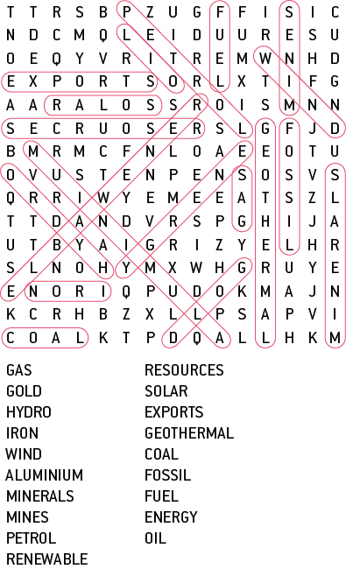

4.3 Renewable resources can be harnessed to provide energy

Literacy support worksheet answers (pages 66–67)

Renewable energy

1 Fill in the renewable energy source from below that matches with the correct advantages and disadvantages listed in the table.

|  |  |  |
| --- | --- | --- |
| Renewable resource | Advantages (global) | Disadvantages (local) |
| Wind energy | No pollution (emissions)  Little environmental impact | Wind needs to be blowing  Visually not desired |
| Solar energy | No pollution (emissions)  Natural source of energy | Relies on the Sun being present  Expensive to make and organise (infrastructure) |
| Geothermal energy | Constant energy source  Cheap source of energy | Expensive to make and organise (infrastructure)  Long-term impact on the Earth not yet known |
| Hydroelectric energy | Renewable energy source  Stores water for other uses | Requires large dams and flooding of valleys |
| Tidal energy | Offshore, so there is little visual impact  Constant source of energy | Expensive to make and organise (infrastructure)  Impact on the local ecosystem |

2Provide real-life examples of how you have experienced a renewable energy resource. For example, ‘I have visited the hot springs in New Zealand’ could be your experience of geothermal energy.

aThe power of the wind:

Student responses will vary but could include standing outside on a very windy day.

bThe power of the Sun:

Student responses will vary but could include getting sunburnt or suffering heat stroke during summer.

cThe power of the waves or tides:

Student responses will vary but could include getting knocked over by a wave at the beach.

dThe power of flowing water:

Student responses will vary but could include standing in a strongly flowing river.

e The power of the Earth’s heat:

Student responses will vary but could include seeing a volcano or geyser.

WORD DETECTIVE

3 Fill in the blanks

Fill in the blanks using the following words:

Wind energy is moving air. The wind turns large windmill-like blades to produce electricity. Solar panels turn the Sun’s light into electricity. Hydro energy involves water flowing from a dam over turbines. Geothermal energy uses heat stored below the Earth’s surface to generate power. Tidal energy involves a dam or barrage being built and water is pushed through turbines to generate electricity.

4.4 Non-renewable resources are limited

Literacy support worksheet answers (pages 68–69)

Fossil fuels

1 Review your understanding of the formation of coal by describing what happens at each stage:

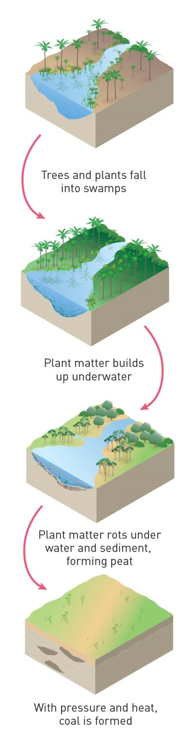

2 Using the ‘formation of coal’ diagram as a guide, draw a simple flow-chart to explain how oil and gas were formed.

Plants and animals died and were washed into swamps. → Layers of plant and animal material were covered in sediment. → Over time (millions of years), water pressure and heat caused chemical reactions that turned the plant (and animal) material into fuels like oil and gas. → The oil and gas travelled through porous rock until they became trapped in non-porous rock.

3 Why is the formation of coal, oil and gas so similar?

The formation of coal, oil and gas is similar because they all came from animals and plants that died, were covered by sediment and then underwent chemical reactions to convert them into fossil fuels.

WORD DETECTIVE

4 Secret message

Use words from the student book to work out the secret message below:

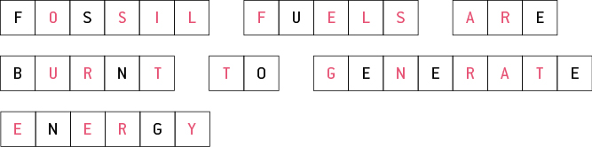

4.5 Soil is one of our most valuable resources

Literacy support worksheet answers (pages 70–71)

Soil as a resource

1 What ingredients make good soil?

A mixture of sand, silt, clay and humus, as well as minerals, makes good soil.

2 The diagram below is a soil profile and shows the different layers in the soil.

a Use the following words to label the different layers of the soil profile:

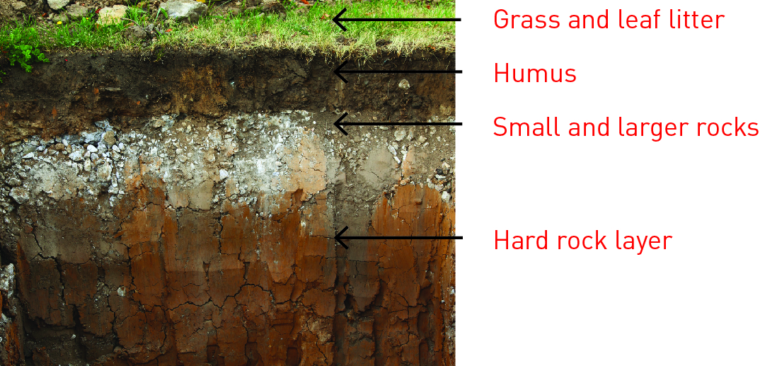

b Which layer of the soil would you find decomposed plants and animals in?

Humus would contain decomposed plants and animals.

WORD DETECTIVE

3 Crossword

Read the clues below and complete the crossword.

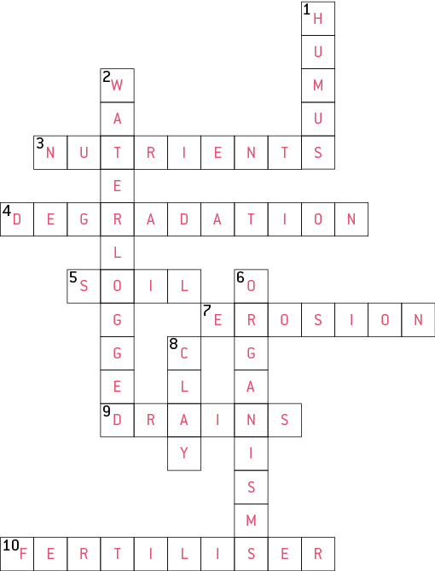

4.6 Our future depends on careful management of resources

Literacy support worksheet answers (pages 72–73)

Resource management

1 Complete the following sentences.

a LEVs are:

low emissions vehicles

b Hybrids use a mix of:

petrol and electricity

c Ethanol is a type of:

alcohol

2 What could the ‘smart home’ of the future do to manage resources in these situations?

a You left your bedroom light on when you left for school.

A ‘smart home’ would switch off the lights when the Sun comes out.

b You also left the television on.

A ‘smart home’ would send you an alert so you could turn off the television remotely.

c You flush the toilet.

A ‘smart home’ uses gravity-fed rainwater tanks located under the eaves to flush toilets.

WORD DETECTIVE

3 Mumbo-jumbo

a Use the marked letters to find the secret word (e.g. olusntoi = solution).

b Unscramble each of the clue words below to find the message.

Secret word: TECHNOLOGY

O

O

Message: HOMES OF THE FUTURE WILL GENERATE ELECTRICITY

4.7 Science as a human endeavour: Green jobs will increase in the future

Literacy support worksheet answers (pages 74–75)

Green jobs

The images below show different people working in green jobs.

Choose one of the green jobs – think about what that person’s job might be and imagine that you are that person, then complete the sentences.

1 My job:

Student responses will vary depending on the ‘green job’ they have chosen and their interpretation of the image.

2 The ways my job helps the environment in the future is:

Student responses will vary depending on the ‘green job’ they have chosen, but factors linked to the environment, sustainability, renewable energy, climate change etc. could be considered.

WORD DETECTIVE

3 Word search

Find as many words as possible in the puzzle below.

